**PRACTICAL WORK BOOK**

**For The Course**

**EE-383 Instrumentation & Measurement**



For

**5th Semester**

(B.Sc. Electrical Engineering)

|  |  |  |
| --- | --- | --- |
| **Lab No.** |  | |
| **S.No.** | Name | Registration No. |
|  |  |  |
| **Syndicate** |  | |
| **Submission Date** |  | |

**DEPARTMENT OF ELECTRICAL ENGINEERING**

**College of Electrical & Mechanical Engineering (CEME), NUST-Pakistan**



**Calculation of Probability of Error using experimentally obtained Data**

**Experiment No 01**

**Objective:**

* To do statistical analysis of measurements subject to random errors.
* To use graphical data analysis techniques i.e. frequency distributions, Gaussian distribution.

# Apparatus:

-Digital Multi Meter,

-Resistors (fixed) 1kΩ x 100, 2.2kΩ x 100, 10kΩ x 100

-Breadboard

# Theory:

*Random Error:*

Random errors in measurements are caused by unpredictable variations in the measurement system. They are usually observed as small perturbations of the measurement either side of the correct value, i.e. positive errors and negative errors occur in approximately equal numbers for a series of measurements made of the same constant quantity.

Therefore, random errors can largely be eliminated by calculating the average of a number of repeated measurements, provided that the measured quantity remains constant during the process of taking the repeated measurements. This averaging process of repeated measurements can be done automatically by intelligent instruments. The degree of confidence in the calculated mean/median values can be quantified by calculating the standard deviation or variance of the data, these being parameters that describe how the measurements are distributed about the mean value/median.

*Mean and median values:*

The average value of a set of measurements of a constant quantity can be expressed as either the mean value or the median value. As the number of measurements increases, the difference between the mean value and median values becomes very small. However, for any set of n measurements x1, x2, …. xn of a constant quantity, the most likely true value is the mean given by:



This is valid for all data sets where the measurement errors are distributed equally about the zero error value, i.e. where the positive errors are balanced in quantity and magnitude by the negative errors.

The median is an approximation to the mean that can be written down without having to sum the measurements. The median is the middle value when the measurements in the data set are written down in ascending order of magnitude. For a set of n measurements x1,x2, …. xn of a constant quantity, written down in ascending order of magnitude, the median value is given by



**The smaller the spread of the measurements, the more confidence we have in the mean or median value calculated. The median value tends towards the mean value as the number of measurements increases.**

*Standard Deviation and Variance:*

Expressing the spread of measurements simply as the range between the largest and smallest value is not in fact a very good way of examining how the measurement values are distributed about the mean value. A much better way of expressing the distribution is to calculate the variance or standard deviation of the measurements. The starting point for calculating these parameters is to calculate the deviation (error) di of each measurement xi from the mean value xmean:



The variance (V) is then given by:



The standard deviation (δ) is simply the square root of the variance. Thus:

*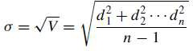Graphical data analysis techniques – frequency distributions:*

Graphical techniques are a very useful way of analyzing the way in which random measurement errors are distributed. The simplest way of doing this is to draw a histogram, in which bands of equal width across the range of measurement values are defined and the number of measurements within each band is counted. Below is a histogram having the characteristic shape shown by truly random data, with symmetry about the mean value of the measurements.

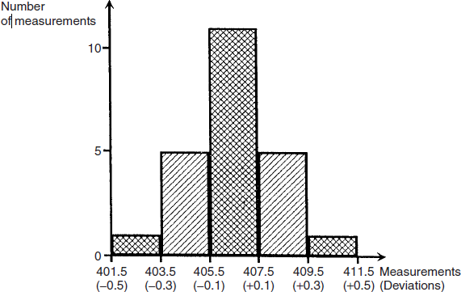

As it is the actual value of measurement error that is usually of most concern, it is often more useful to draw a histogram of the deviations of the measurements from the mean value rather than to draw a histogram of the measurements themselves. The starting point for this is to calculate the deviation of each measurement away from the calculated mean value. Then a histogram of deviations can be drawn by defining deviation bands of equal width and counting the number of deviation values in each band.

*Gaussian distribution:*

Measurement sets that only contain random errors usually conform to a distribution with a particular shape that is called Gaussian. The shape of a Gaussian curve is such that the frequency of small deviations from the mean value is much greater than the frequency of large deviations. This coincides with the usual expectation in measurements subject to random errors that the number of measurements with a small error is much larger than the number of measurements with a large error. Alternative names for the Gaussian distribution are the Normal distribution or Bell-shaped distribution.

# Procedure:

› Measure the value of resistance of each resistor in the given batch, (e.g. 100 resistors), using DMM.

› Note down all the measured values of resistances in tabular form or an excel sheet containing above data can be obtained.

› Calculate mean, median, standard deviation and variance for the above obtained data.

› Plot data to obtain frequency distribution curves.

***Note:***

***All readings to be taken from the same instrument*.**

# Observations:

|  |  |  |  |
| --- | --- | --- | --- |
| Mean | Median | Standard Deviation | Variance |
| 14.5002 | 14.5300 | 0.4030 | 0.1624 |

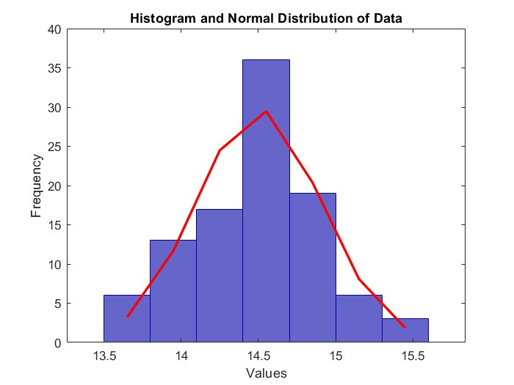Frequency vs. Measurements (values range) curve

Frequency vs. Deviations (deviation range) curve

|  |
| --- |
|  |